**Form Configuration using reference marker**

**Step 1**: pdf to png conversion *(Manual conversion using Acrobat Reader)*

* *File -> Save As Other -> Image -> PNG*
* *In the settings tab, set the resolution to 250 pixels/inch*
* *Multiple png files would be created in the output folder*
* *Create a new output folder, or ensure the folder is clean*

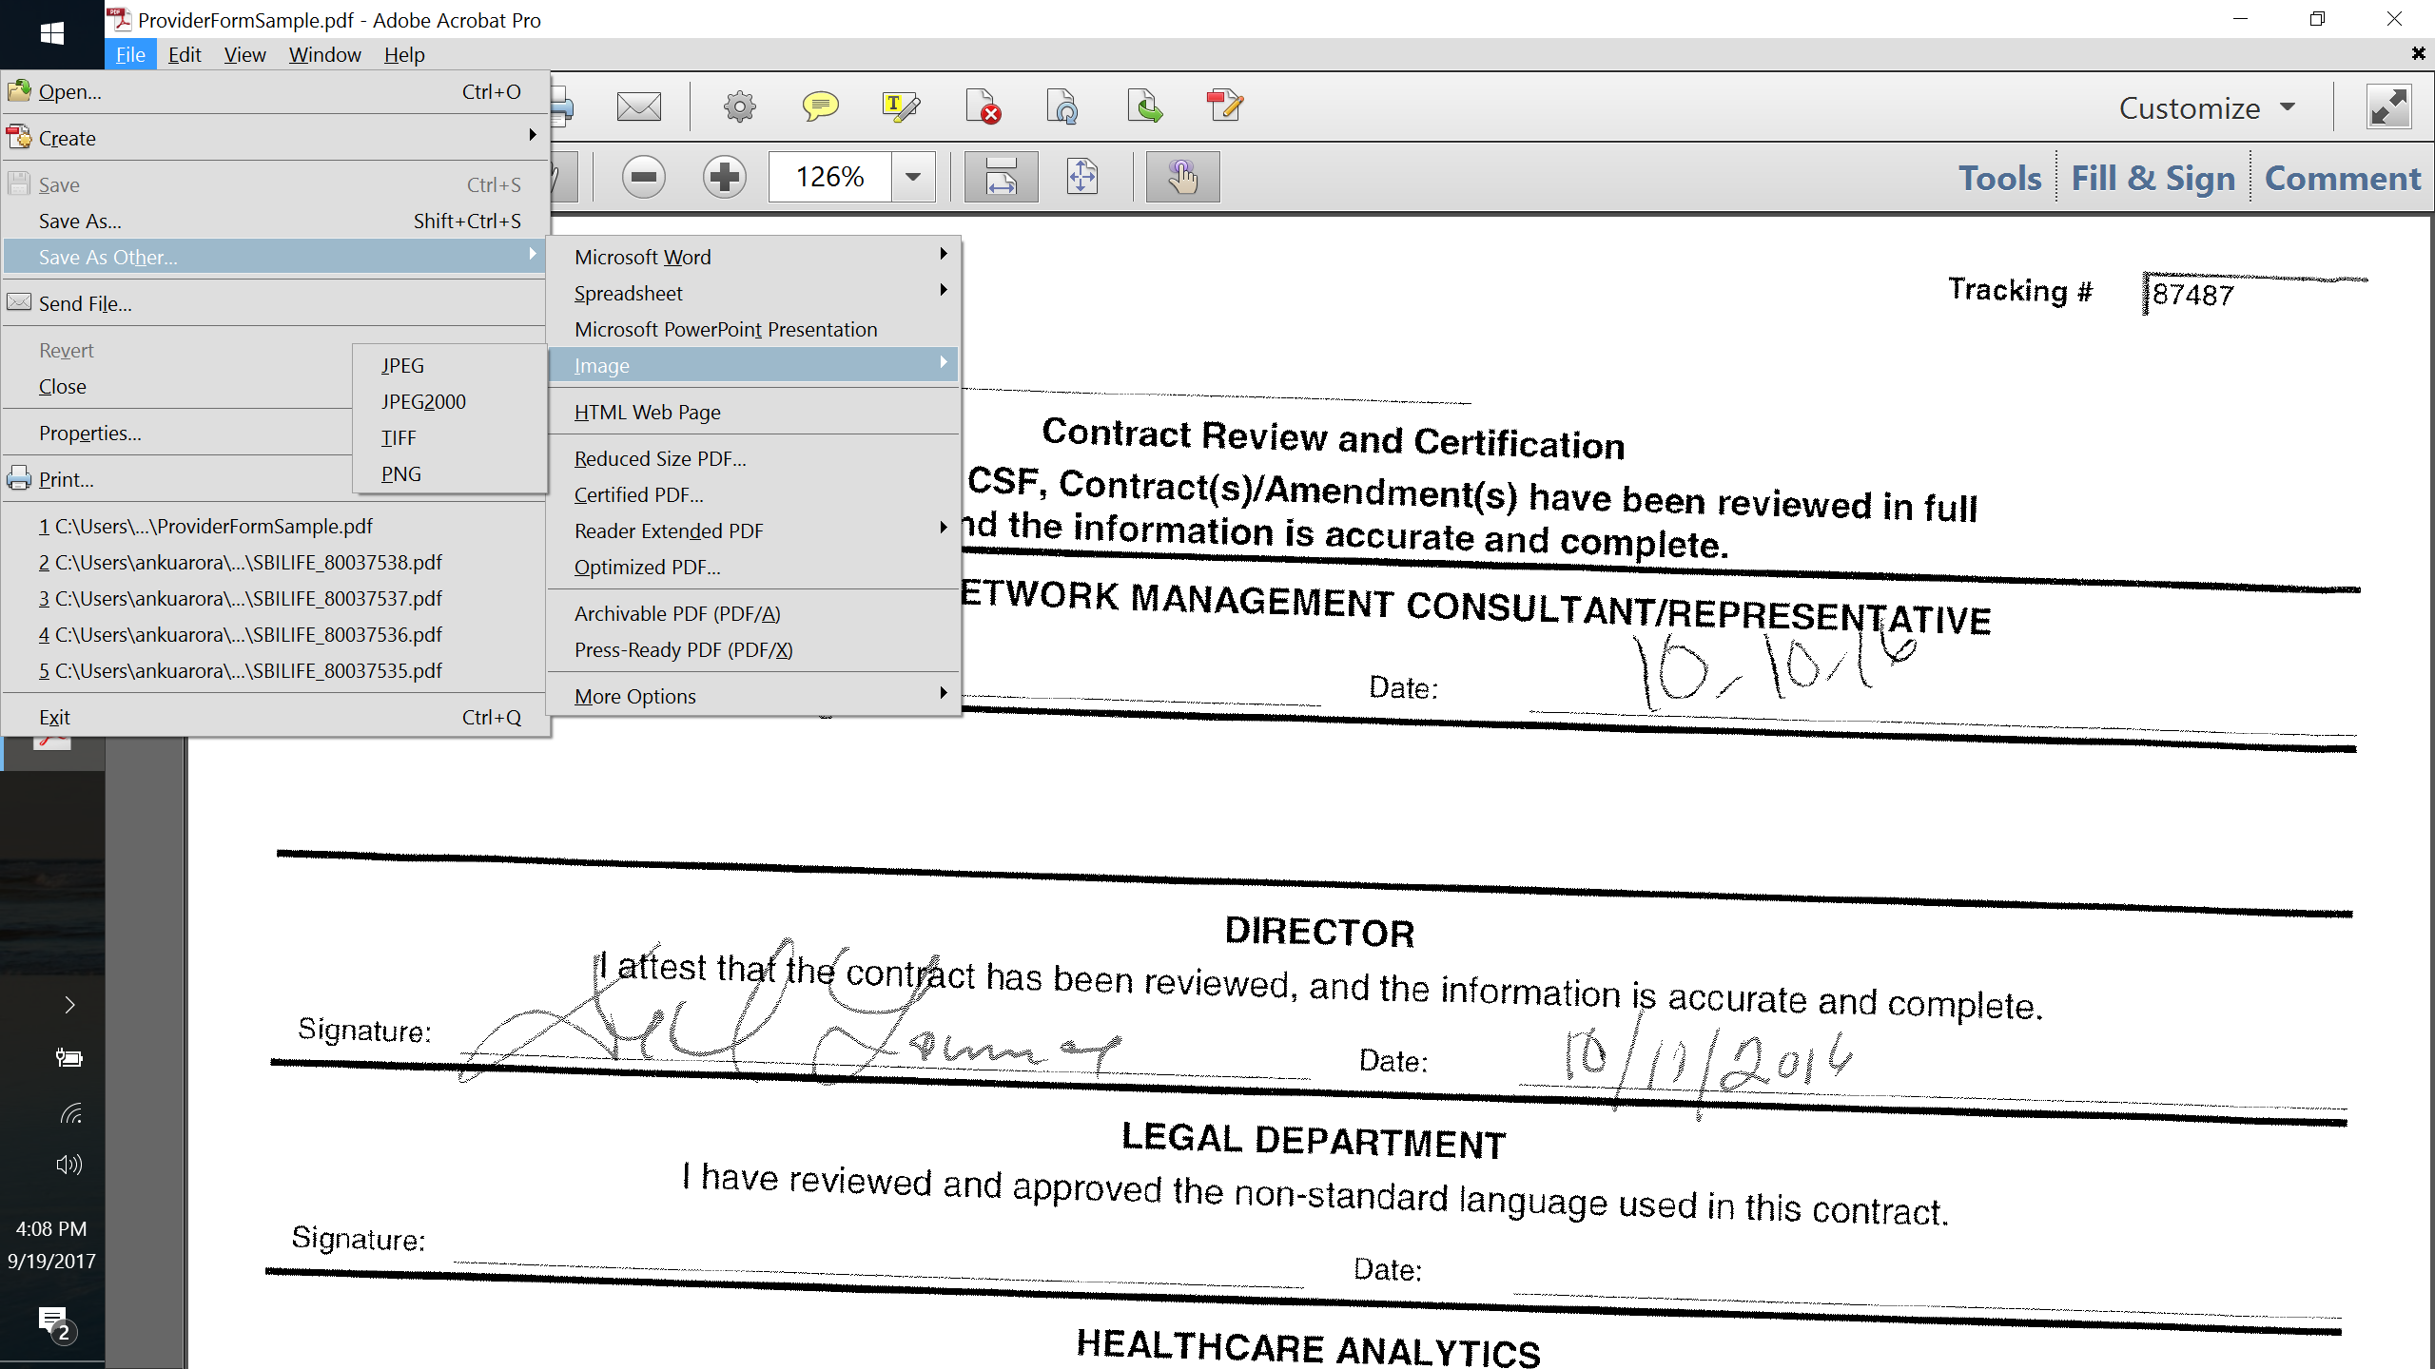

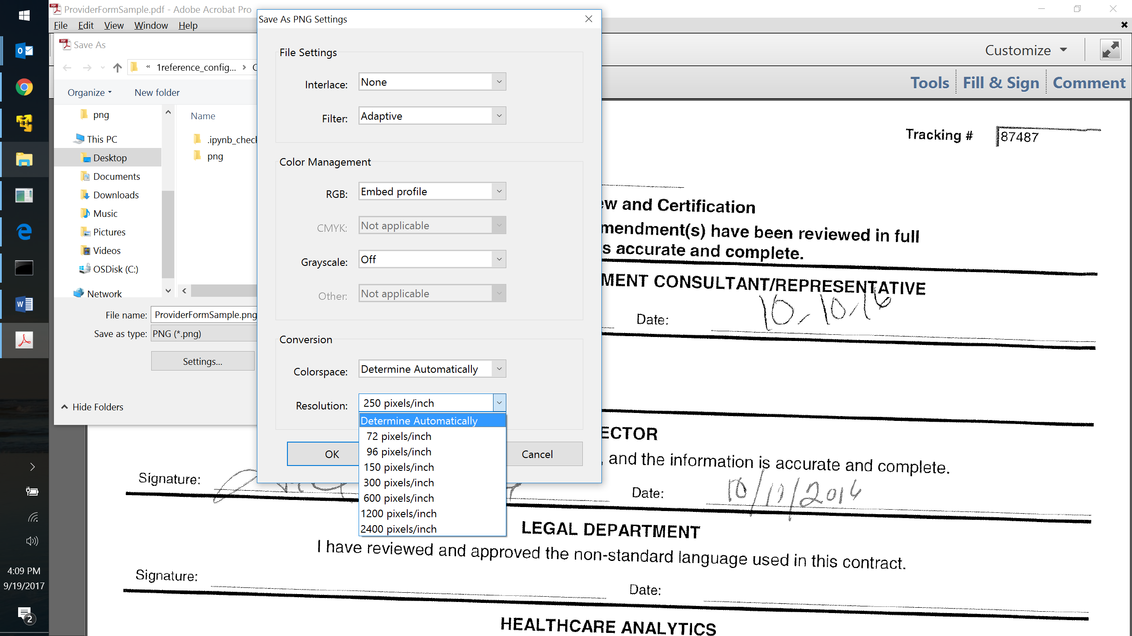

**Step 2**: Merge to single png *(attached python utility)*



* *Extract the python file in the folder containing the png file(s)*
* *Use the following command:*

*python png_merge.py*

* *Output -> merged.png*

**Step 3**: Find coordinates for marker and fields (manual, iterative process)

* *Identify the coordinates for the marker and the corresponding field by manually setting & adjusting the values recursively on the merged form*
* *Use the attached Jupyter notebook for the same*
* *An additional marker named ‘Form Header’ would need to be identified. This would help determine the appropriate aspect ratio to be used for the ingested form and marker templates.*



**Step 4**: Creating the coordinate based configuration (attached excel utility)

* *For each field to be configured in the form, identify the field name and the type.*
* *Add the python commands for marker and field identification (with other required details) in the designated areas of the attached excel*
* *The corresponding field configuration is created automatically*
* *Create a consolidated .json file with configurations for all fields appended. Refer to the attached sample.*



**Step 5**: Creating a generic marker based configuration

* *Extract the python file in the folder containing the merged png & the coordinate configuration created in step 4 (say, coordinate_config.json)*
* *Use the following command:*

*python 1reference_config_creation.py merged.png coordinate_config.json*

* *Output -> a marker based configuration file (coordinate_config_base64.json)*
* *Sample output configuration attached for reference*

